

**Independent University Bangladesh**

Assignment 1

**PIC 16F877a Pin Diagram and Brief Explanations**

**Submitted By:**

**Name:** Injamamul Haque Sourov

**Id:** 1820170

**Course Id:** EEE 334

**Course name:** Embedded Systems

**Semester:** Autumn 2020

**Faculty:** Mr. Mohammad Rejwan Uddin

PIC 16F887A Pin Diagram for reference:

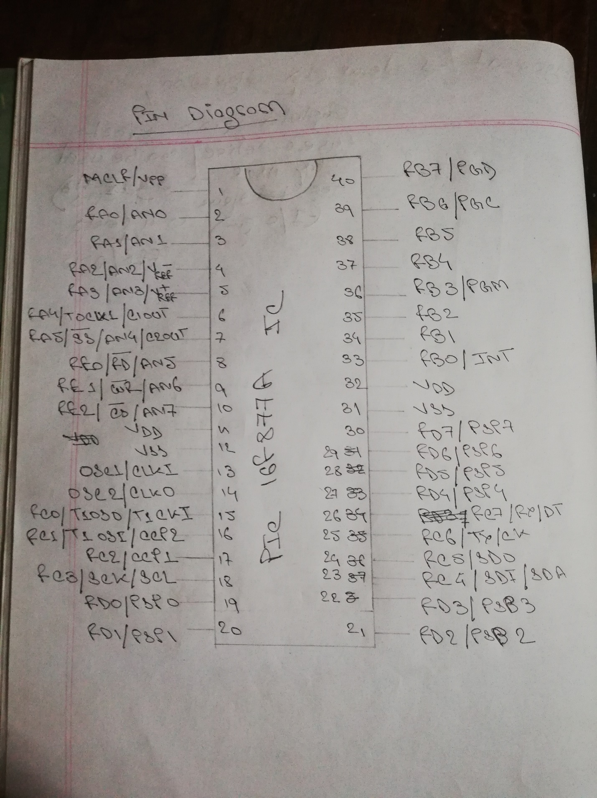

Intro:

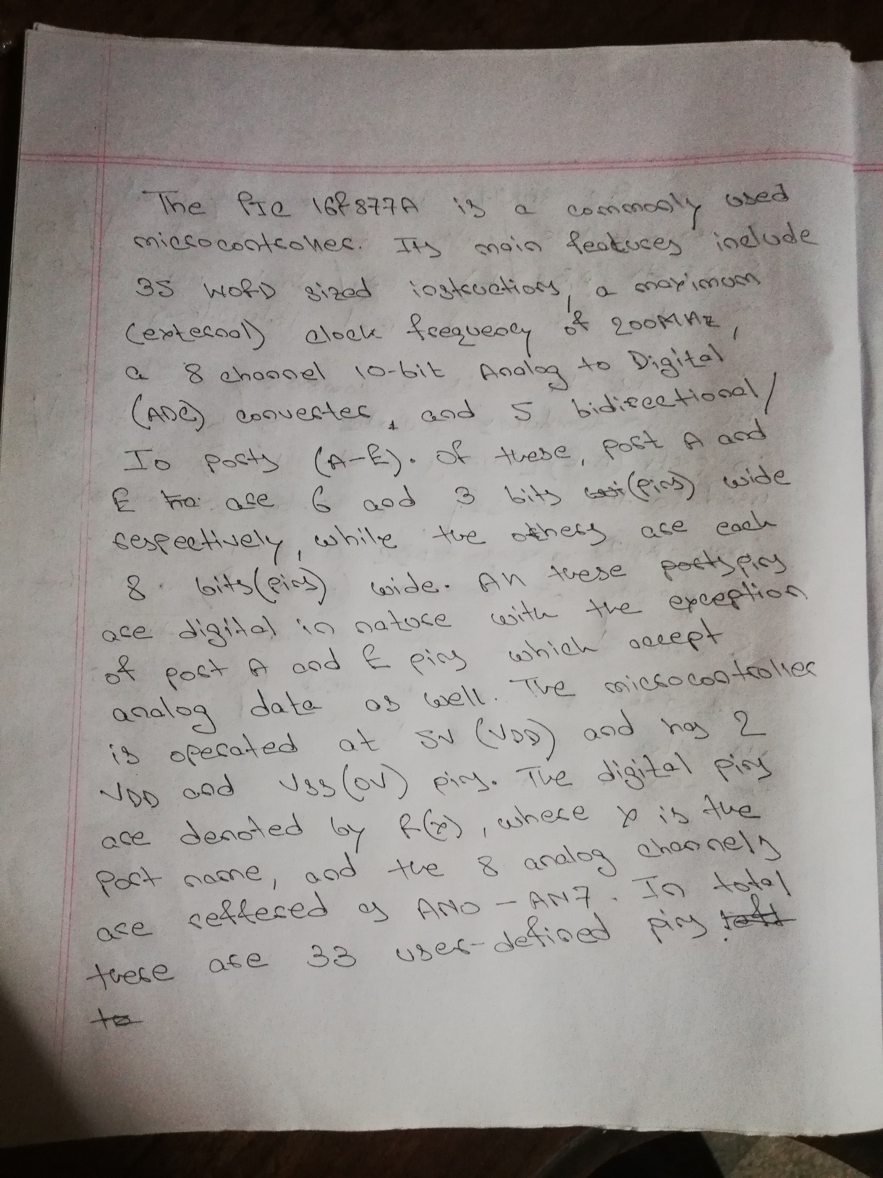

Brief explanation of pins:

.